**Real-Time Detection of Safety Compliance and Hazardous Events in the Firecracker Industry Using YOLO**

|  |  |  |  |  |  |
| --- | --- | --- | --- | --- | --- |
| |  |  | | --- | --- | | ***A. RAYHON SAMO***  *IT Department*  *Thiagarajar College of*  *Engineering*  Madurai, Tamil Nadu, India  [rayhon@student.tce.edu](mailto:rayhon@student.tce.edu) | **C.V Nisha Angeline**  *IT Department*  *Thiagarajar College of*  *Engineering*  Madurai, Tamil Nadu, India  cvnait@tce.edu | | |  |  | | --- | --- | | **S. SUBASH**  *IT Department*  *Thiagarajar College of*  *Engineering*  Madurai, Tamil Nadu, India  ssubash@student.tce.edu | **R.S. Shriram**  *IT Department*  *Thiagarajar College of*  *Engineering*  Madurai, Tamil Nadu, India shriramrs@tce.edu | |

***Abstract*— The firecracker manufacturing industry faces too many risks due to compliance protocols, improper chemical handling issues and less real-time monitoring, because of which many workers suffer a lost and this is too risky both to the environment and workplace safety, this study aims to enhance the safety, monitoring and compliance of firecracker manufacturing by integrating many real-time technologies.**

**our approach consists of the Internet of things (IOT) for real-time environmental monitoring. Cloud-based (AWS) solutions for compliance and Machine Learning (ML) based model for real-time risk assessment. Smart sensors for continuous monitoring of fire and smoke.**

**In order to create awareness among the employees we have also developed a gesture-based simulation using the MediaPipe python library.**

**The proposed system solution enhances the safety of the workers by achieving high accuracy in detecting real-time hazards. This research presents a scalable and reliable solution for improving workplace safety, reducing the hazards and mitigating the environmental risks in the firecracker manufacturing industry.**

***Keywords— Deep Learning, Machine learning, Gesture Based Simulation, Sensor data, Industrial safety, Feature extraction***

# I. INTRODUCTION

The firecracker manufacturing industry goes through a significant transformation to address critical safety related concerns associated with improper chemical handling, less real-time monitoring and outdated compliance measures. These issues faced by them have led to many accidents, toxic exposure and regulatory violations leading to various risks both to workers and the environment. To overcome these challenges our projects, make use of various technologies to enhance the safety, monitoring and compliance within the industry.

Our Solution establishes safety framework by combining cloud-based (AWS)Solutions, Machine Learning (ML), and the internet of things (IOT).

The ML-based models detect and stops safety violations, IOT-based real-time monitoring prevents hazard by monitoring the environment, thus leading to a safer working environment for the workers of the firecracker industry.

IOT-based sensors are deployed for continuous tracking of workplace temperature, fire, and smoke.  
various deep learning models such as YoLov8, YoLov9, YoLov10, and YoLov11 are used to analyze the workplace environment and detect hazards. These are had been trained with datasets and tested using IoT gadgets to ensure reliability and accuracy. Additionally we have also developed a Chemical mixing simulation using python’s MediaPipe library to train the new employees with gesture actions, thus giving them a view of how the working process is going to be in the workplace.  
  
This project aligns with several Sustainable Development Goals (SDGs), which includes promoting worker safety (SDG 3),ensuring a safer work environment (SDG 8), modernizing manufacturing with technology (SDG 9), and optimizing resource consumption (SDG 12). By integrating this modern engineering principles such as IoT sensors, deep learning, embedded systems, and cloud, this project aims to set a new benchmark in safety and efficiency in firecracker industries.

# II. LITERATURE REVIEW

Dr. C. Guna Sundari proposed a study on the health problems faced by women in the firecracker industry in Sivakasi [1]. The study highlights various dangerous working conditions, such as exposure to dangerous chemicals and insufficient ventilation to breath. Women face lot of struggles because of less number health care facility centers, improper safety regulations and suffer because of nutrition less food.

The difficulties of the Sivakasi fireworks industry, which produces 90% of India's fireworks, have been studied by Sivaramakrishnan. M and Shri Hari Priya. K [2]. They identified various issues, including poor working conditions, lack of worker safety equipment, frequent accidents, health risks to workers, and the continued use of child labor. The industry is focusing on a change to "green crackers" in order to decrease chemical emissions.

A study on social, legal, and welfare justice for Sivakasi firecracker industrial workers was carried out by Janani M, Lakshmi Praba K B, Sai Darshini S K, and Ramanya Gayathri M [3]. The team suggested about stronger safety regulations, more welfare benefits like government subsidies and recreational facilities, and more effective awareness campaigns and skill-building initiatives for workers working in the industries.

K. Jeyaram and Dr. G. Karunanithi explored the various challenges faced by firework manufacturers in Virudhunagar District, Tamil Nadu, focusing on a change to green crackers [4]. They identified the following manufacturing processes, high investment requirements, limited availability of raw materials and skilled Labour, low consumer awareness, and more storage space green crackers.

Dr. Vidya Hattangadi used Michael Porter's Diamond Model [5] to identify how environmental regulations and unforeseen events, such as the COVID-19 pandemic, affected Sivakasi's firecracker industry. The study focuses on issues such as state-wide bans on fireworks, the slow acceptance and change to "green crackers" due to a lack of technically skilled workers.

The effects of conventional versus eco-friendly firecrackers on the environment and human health were identified by Sweety Mehra, Govind Mawari, Naresh Kumar, Mradul Kumar Daga, M. Meghachandra Singh, T.K. Joshi, Manish Kumar Jha, and Amrapali Kunwar [6]. Eco-friendly firecrackers have very a smaller number of harmful components, which results in lower emissions of particulate matter, SOx, and other pollutants than traditional firecrackers, which contain chemicals that can cause serious health problems.

Jean D. Bondal and Marvin I. Noroña identified outdated and insufficient safety measures in their study of the risks associated with firecracker manufacturing in Bulacan, Philippines [7]. The Risk Priority Number (RPN) was reduced by 56.15% using their proposed risk management framework, that was based on ISO 31000. areas of improvement included the use of personal safety devices, updated safety regulations, and ventilations.

|  |
| --- |
|  |

S. Ajith, C. Sivapragasam, and V. Arumugaprabu [8] identified the challenges faced by the firecracker industry workers in Sivakasi, Tamil Nadu. They noted sudden spike in dangerous gases and its particulates during the holidays, the important manual handling of chemicals, and the serious health risks caused by chemical and firework smoke exposure. Methods such as Chemical Health Risk Assessment (CHRA) and Safety Risk Assessment.

P. Sonika and Dr. P. Shyamala identified safety related practices and causes of accidents in the fireworks industry in Sivakasi [9]. Key causes of accidents included lack of awareness about chemical reactions, carelessness while making fireworks, long working hours, not having a separate space for works which may cause high fire risks of, and lack of safety measures.  
  
Dhruv Katoria, Dhruv Mehta, Dhruv Sehgal, and Sameer Kumar identified workplace problems faced by workers in the fireworks industry such as in manufacturing processes, exposure to chemicals, and associated risks [10]. Primary risks identified were production injuries caused by impact, friction, static electricity, and human errors during manual mixing of chemicals, explosion injuries, and chemical exposure leading to respiratory issues, organ damage, and release of toxic from chemicals.

# III. DESIGN AND METHODOLOGY

## A. Dataset Description and Dataset Pre-Processing

The dataset used in this project consists of images which are specifically curated for PPE Detection and Fire/Smoke detection. This includes labelled images representing a huge range of images of safety equipment like hardhat, masks, safety gears and also includes images of Fire and Smoke. Each image is annotated in such a manner which allows the model to learn complex hazards in the fire cracker industry. The images vary in resolution and lighting to adapt to the real-life scenarios to simulate the real-life variations in surveillance footage.

In total the dataset is organized into three major subsets, around 10000 images for training 1000 images for validation and 700 images for testing. This ensures the model can perform well across data. All labels are formatted to match the yolo object detection standards. This makes the model more accurate and performs well across all scenarios.

Prior to model training, the dataset was organized into corresponding test, train, and valid directories containing corresponding image and label files. The label files are specifically of yolo format, giving object coordinates in relation to image dimensions. A custom data.yaml configuration was set up to specify the dataset, where each subset's paths are clearly stated, as well as the total number of classes and their respective names. This setup natively supports the integration with the YOLO pipeline, making sure that the dataset is identified properly during training and testing.

As a part of preprocessing, the images are automatically resized during model training to match the expected input size, maintaining the aspect ratio of the image whenever necessary. Image augmentations such as horizontal flipping, scaling and color adjustments are applied dynamically during the training phase to improve the model’s accuracy to different types of visual conditions. Normalization of pixel values is handled automatically by the yolo framework to enable uniform input ranges for effective learning. Generally, the dataset Preparation and Pre-Processing steps are intended to make the model more effective in detecting various types of objects in dense real-time hazardous environments.

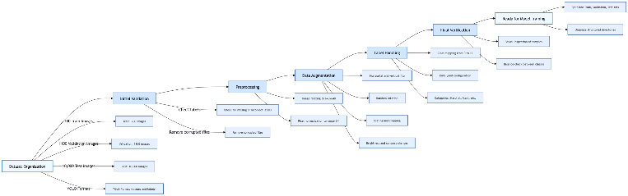

Fig. 1. Dataset Pre-processing

## B. Methodology

In the visual safety detection Framework, it adopts a multi-layered approach like combining IoT Hardware AI/ML, and cloud infrastructure to monitor and enhance safety in firecracker manufacturing.

1. data acquisition:

in the framework iot sensor like dht11/22, gas, pulse oximeter sensor are deployed in real time to collect Temperature (DHT11/MLX90614), Humidity, Toxic gas levels (MQ-2, MQ-135), Flame/Smoke detection (Flame sensors, camera modules), Worker vitals (heart rate, body temp via wearable devices).The sensor data is then sent to fog node or edge processor(raspberry pi/esp32) and then pushed to the cloud platform like AWS IoT core for storage and analysis for future works.

1. AI-based safety detection:

We have developed the deep learning models to analyze any unsafe working conditions and sensor data to Detect PPE (Personal Protective Equipment) violations (e.g., no helmet or vest), Identify smoke or fire, Monitor abnormal environmental readings. Models includeYOLOV11 for real time object detection (PPE violation, smoke & fire), Resnet50 for classification of safety compliance, Custom CNN for baseline classification (Directly classifies image, no region proposal or refinement.)

1. Cloud-Based Compliance & Alert System

Sensor readings and model predictions are stored in the cloud platform like AWS IoT core for analysis pupose. the model is deployed in platform like hugging face for real time processing. analytical dashboard shows the real-time stats and notifies supervisors about hazards.

1. Worker Training & Feedback System

A mobile/web-based platform provides **interactive safety training** modules.

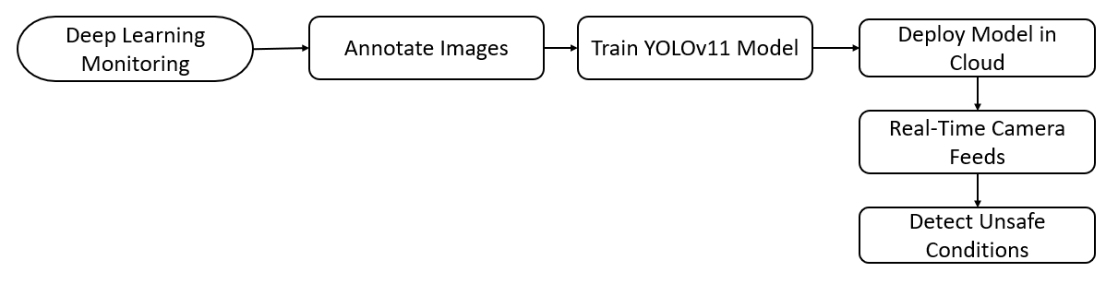

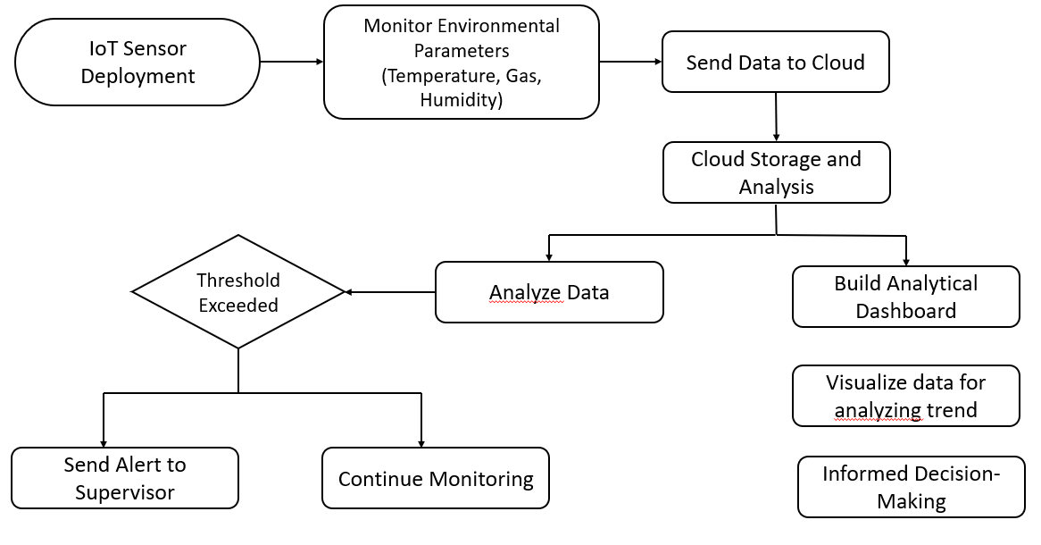

## C. Object Detection Models

These models are capable of both classifying and localizing objects within an image suitable for real time monitoring.

YOLOv8 (You Only Look Once version 8) is the latest addition to the YOLO object detection family developed by Ultralytics. It is a single-stage detector that scans the whole image in a single forward pass, which makes it very fast during inference time and very accurate. YOLOv8 has a lot of improvements over its predecessors, such as an anchor-free detection head, new backbone network, and support for instance segmentation. They are particularly improved for real-time scenarios like pharma quality control, where speed as well as accuracy is the demand. On the project, YOLOv8 produced the best detection results among all the models  
with 76.1(%) accuracy, 74.7(%) precision.

Yolov11 is a state-of-the-art object detection algorithm possesses optimized anchor-free detection heads, and enhanced spatial pyramid pooling for enhanced multi-scale feature extraction.it utilizes convolutional architecture along with state-of-the-art modules such as PANet (Path Aggregation Network) to improve both localization and classification tasks. Important parameters are the size of the input image used is 640*640, confidence threshold, Intersection over Union (IoU) threshold for non-maximum suppression, learning rate, and batch size. To enhance accuracy, methods like exhaustive data augmentation (mosaic, mixup, and HSV color-space augmentations), label smoothing, dynamic learning rate scheduling (cosine annealing).

In this work, we have used RF-DETR (Roboflow-DETR), a powerful and effective object detection framework built on DETR (Detection Transformer). RF-DETR utilizes transformer-based attention methods in combination with convolutional backbones to enhance detection efficiency with lowered computation complexity. We trained the model to detect essential safety items in firecracker production facilities, such as fire, smoke, and compliance of worker safety accessories (helmets, vests, masks). In order to improve model accuracy, hyperparameter tuning need to done by adjusting parameters like the learning rate(initially it would be 0.0002), batch size (16 to balance memory and generalization), encoder-decoder layer numbers (6 for each to represent complex spatial relations). Moreover, data augmentation methods such as random flipping, scaling, color jitter, and mosaic augmentation were used to enhance model generalization over diverse factory environments. RF-DETR's mAP@0.5 and mAP@0.5:0.95 values stabilized remarkably during training, as indicated in Figure [ref], with strong performance even under adverse real-world conditions, essential for reducing fire risks and enhancing worker safety in the firecracker manufacturing sector.

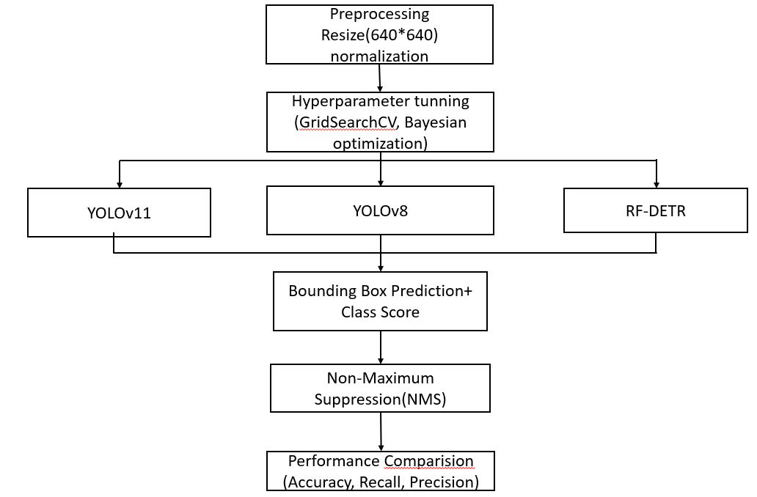

Fig. 3. Object Detection Model Training

## D. Image Classification Models

**ResNet50** is used for deep image classifier to detect unsafe work environments. It is Pre-trained on ImageNet and fine-tuned with an adaptive learning rate and SoftMax layer, it excels in identifying subtle visual hazards. ResNet50 has 50 layers uses skip connections that passes information across layers for feature learning.it has around 25 million parameters and follows a bottleneck design with 1×1, 3×3, and 1×1 convolutions within its residual blocks to reduce computational load while maintaining performance. ResNe50t accepts standard input sizes like 224×224×3 and is often pre-trained on ImageNet for transfer learning.

VGG16 is a very deep model with consistent architecture; high feature extraction capacity. Its consistent structure with 16 weight layers (13 convolutional and 3 fully connected). Small 3×3 convolution filters and 2×2 max-pooling layers throughout the network to extract fine-grained spatial features to keep computational complexity. VGG16 contains 138 million parameters, owing to its dense fully connected layers, hence being computationally intensive but strong. The input size is typically 224×224×3 and is pre-trained on large datasets such as ImageNet.

The application-specific Convolutional Neural Network is a slim architecture but effective design with known high accuracy and lower computational complexity. It involves several layers of convolution that are 128, 64, and 32 filters with each having tiny 2×2 kernels for catching local features and max-pooling layers that reduce the spatial dimensions to check overfitting. The light-weight design custom Convolutional Neural Network is efficient architecture but has high accuracy with less computational complexity. It has several convolutional layers with 128, 64, and 32 filters, each of them has small kernels of size 2×2 to extract local patterns, and then max-pooling layers to decrease spatial dimensions and regulate overfitting.

All the models are trained using image dataset collected from firecracker industry. The dataset is preprocessed using standard normalization and data augmentation techniques like flipping , rotation, cropping etc and labelled for classification tasks. Dataset is divided into 80% training and 20% validation. Each model is evaluated using metrics like **mean Average Precision (mAP)**, **accuracy**, **precision**, **recall**, and **F1-score**.

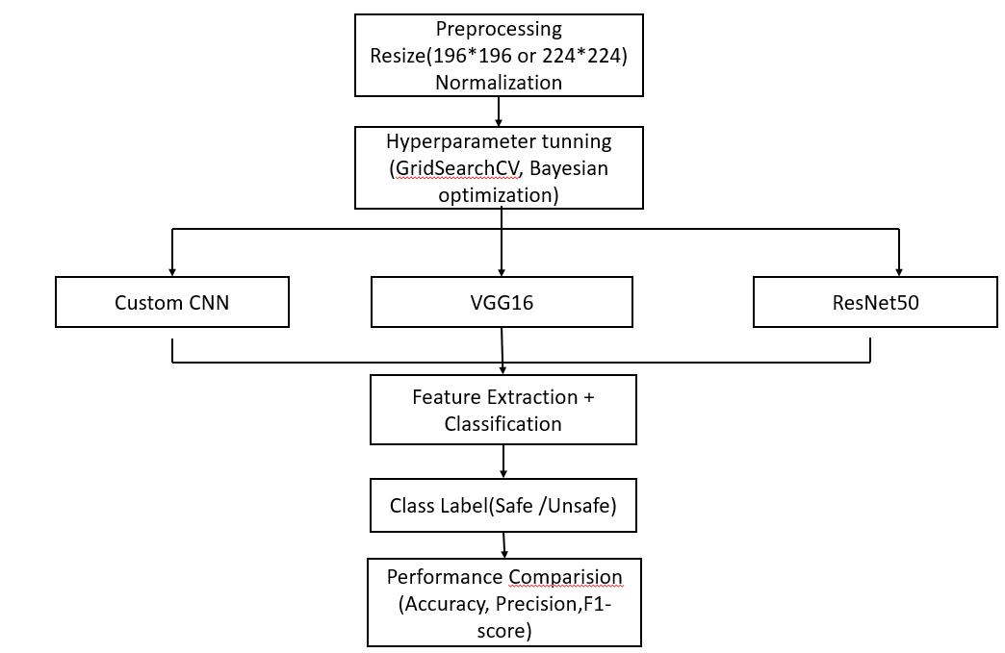

Fig. 4. Image classification model training

By effectively combining all the models the Advantages includeYolov11 – high speed detection for real time monitoring**,** Resnet50 – high classification accuracy**,** SSD – balances speed and accuracy for multi-label image tasks although the drawbacks include YOLOv11 misses small or partially occuleded objects and ResNet50 requires substantial computational power for Training **SSD** can struggle with class imbalance or dense scenes.

Finally we compared the performance of deep learning models –YOLOv11, Simple CNN, ResNet50, SSD, VGG16 – on detecting the PPE violations(helmet/vest/mask), fire & smoke. the evaluation was based on various metrics like accuracy, precision, recall, F1- SCORE, and inference time

# 

# IV. RESULTS AND DISCUSSION

In this section, we present a comprehensive evaluation of deep learning models, comparing their effectiveness in predictive performance. The selections is based on accuracy, which serves as a key metric for quantifying the correctness of model predictions.

**Table 1: OBJECT DETECTION MODELS ACCURACY**

|  |  |  |  |  |  |
| --- | --- | --- | --- | --- | --- |
| Model | Task | Accuray | Precision | F1-Score | Recall |
| YOLOv11 | Object detection | 95.3% | 95.0% | 95.2% | 95.4% |
| YOLOv8 | Object detection | 76.1% | 74.7% | 72.8% | 71.1% |
| RF-DETR | Object Detection | 93.0% | 100% | 93.5% | 100% |

Based on the results of the evaluation, we deduce that YOLOv11 performs better than other models at an accuracy of 95.3%, precision of 95.0%, F1-score of 95.2%, and recall of 95.4%, proving its superiority in real-time object detection with a well-balanced precision and recall.The YOLOv8 model was tested on 1069 validation images with 2536 instances from five classes (Helmet, Vest, Fire, Mask, Smoke). Overall box precision (P) is 0.747 and recall (R) is 0.711. The mean Average Precision at IoU 0.5 (mAP50) is 0.761 and mAP@[.5:.95] is 0.525. While The RF-DETR model showed superior performance in detecting safety violations in the firecracker industry. The model achieved precision of 100% and recall of 100%, indicating perfect classification performance on the validation set. The mAP@50 was at 93.0%, indicating high localization accuracy. The model was also consistent in performance after 10 epochs, with stable mAP values throughout the rest of the training process. These results validate the effectiveness of using RF-DETR to ensure real-time monitoring and detection in hazardous industrial environments like firecracker production. The Visualization plot for Object Detection models can be represented as follows:

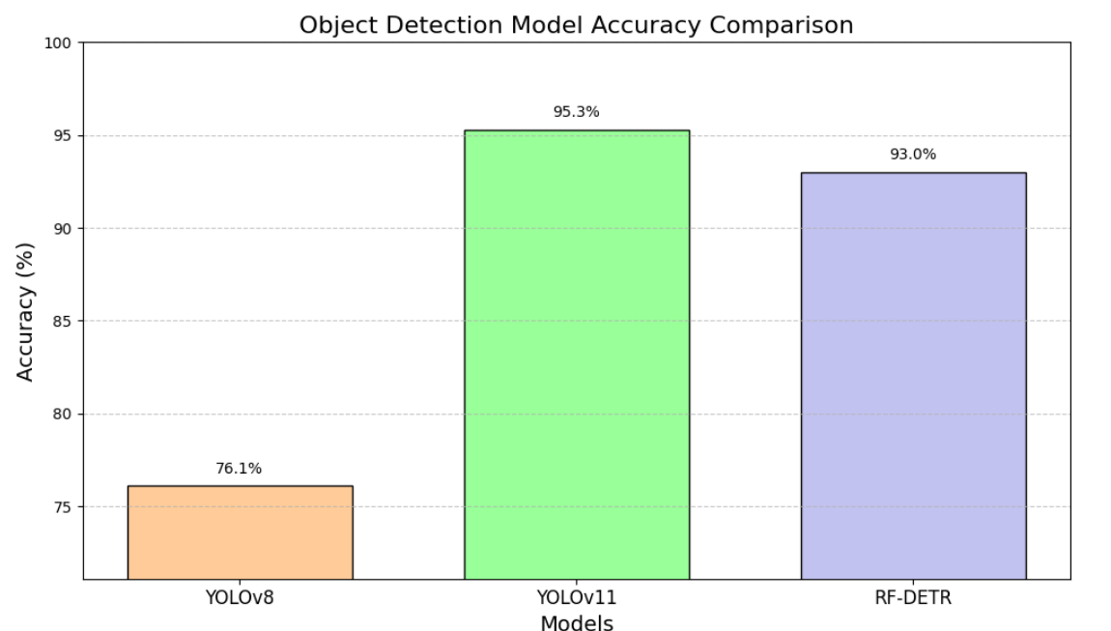

Fig. 5. Object Detection models accuracy comparison

**TABLE 2: IMAGE CLASSIFICATION ACCURACY**

|  |  |  |  |  |  |
| --- | --- | --- | --- | --- | --- |
| Model | Task | Accuracy | Precision | F1-Score | Recall |
| Simple CNN | Image Classification | 79.3% | 79.1% | 79% | 79.2% |
| VGG16 | Image Classification | 79.6% | 79.2% | 79.3% | 79.7% |
| ResNet50 | Image Classification | 91.2% | 91.0% | 90.1% | 91.3% |

From the evaluation results, we conclude that for classification, ResNet50 outperformed other models with the highest accuracy of91.2%, precision of 91.0%, recall of 91.3%, and an F1-score of 90.1%, indicating its high ability to classify different image classes effectively. high ability to classify different image classes effectively.VGG16 was 79.6% accurate and 79.7% recalled with a precision of 79.2% and an F1-score of 79.3%, which reflects moderate classification but reduced feature extraction effectiveness compared to ResNet50.Basic CNN performed slightly poorer, with 79.3% accuracy, 79.1% precision, 79.2% recall, and an F1-score of 79%, indicating that although it offers consistent basic performance, it is not good at handling sophisticated complex image variations.. The Visualization plot for image classification can be represented as follows:

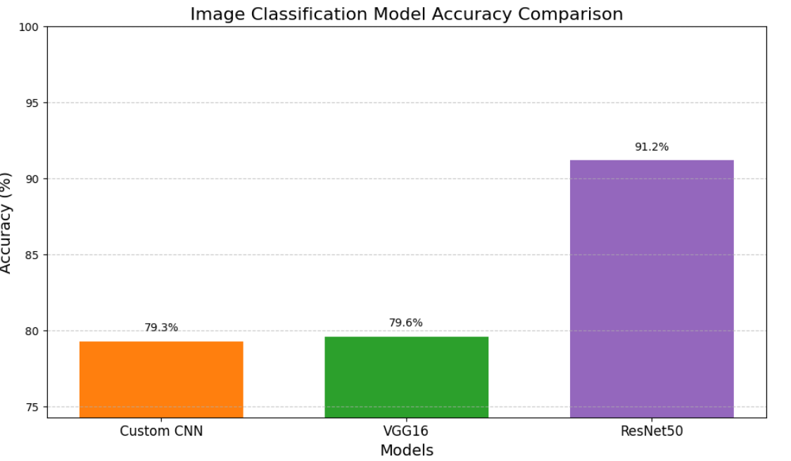

Fig. 6. Image Classification models accuracy comparison

Considering the experimental results as mentioned in the Table 1 and Table 2, **YOLOv11 is the best model that has balance between accuracy, speed, and practical deployment** requirements. It also has the ability to detect, classify, and localize multiple objects in real-time, with high confidence, makes it suitable model for **safety monitoring in fire cracker industry**.

In contrast, the models evaluated for the system revealed a distinct performance across object detection, classification models. Among all models developed, **YOLOv11** shows the highest performance (**95.3% accuracy**), in both localization and classification tasks and is known for its speed and accuracy.

Other detection object model such as, RF-DETR, achieved a staggering 93% accuracy, providing error-free classification performance on the validation set., but the catch is that it takes longer training times because it is over-dependent on attention mechanisms and bipartite matching loss, hence being computationally heavier. Further, RF-DETR's inference time is generally slower than that of YOLOv11, which is a major shortcoming in real-time industrial processes where faster detection is paramount. YOLOv11, however, is designed for record-breaking speed and efficiency without compromising accuracy with a stronger backbone, light-weight attention modules, and dynamic label assignment techniques. RF-DETR occasionally loses small object detection due to the set-based prediction architecture, while YOLOv11 outperforms in small-scale object detection. These collectively illustrate that YOLOv11 is more appropriate for real-time, resource-limited, and object-small-sensitive tasks such as observing safety compliance in the firecracker business.

In image classification models, ResNet-50 performed better compared to other classification method such as VGG16 with 91.2% accuracy, by utilizing deep residual learning to enhance feature extraction. Simple CNN, with 79.3% accuracy, which is less than ResNet-50 due to its parameter dense and very deep leading to slow inference time. It is vulnerable to overfitting on class-imbalanced datasets without regularization. A specially crafted Simple CNN exhibits 79.3% accuracy, doing great in controlled environments but shallow network with weak learning capacity fail to generalize on tough visual patterns.

The comparative analysis demonstrates that object detection models are performing better than classification models in the the proposed system, with YOLOv11 leading in both performance and efficiency**.** While classification models eventhough offer strong image-level accuracy, but their lack of localization restricts their real-world applicability for dynamic hazard detection. It lack in the spatial awareness required for full scene understanding. Thus, **YOLOv11 is a suitable model**, offering robust generalization, faster inference, and high precision in real-time safety monitoring within firecracker manufacturing units.

# V. CONCLUSION

The project work altogether showcases an integrated deep learning model that uses cloud (AWS) and IoT sensors to improve the safety, monitoring, and compliance in the firecracker manufacturing industries, where handling of chemicals and maintaining worker safety are much needed. The developed system has real-time environmental monitoring, predictive risk assessment, and automated compliance measures to prevent accidents, and ensure worker safety.

The use of various deep learning models such as YOLOv8 to YOLOv11, for real-time detection significantly improves the accuracy, reliability, and robustness of safety monitoring systems. The integration of IoT devices for real-time data collection and cloud-based platforms for data analysis and storage improves the functioning and deployment of such systems in dynamic manufacturing environments. Additionally, the development of gesture-based simulations using the MediaPipe library for employee training further improves safety awareness among the workers.  
  
Future research may explore more methodologies, such as convolutional neural networks (CNN) and recurrent neural networks, to capture complex patterns in workplace conditions and chemical handling processes. Real-time implementation of safety monitoring systems using edge computing or IoT frameworks could enhance system efficiency and responsiveness. Safety monitoring systems may become more successful with reinforcement learning, a type of machine learning, where systems continuously update themselves.  
  
This research shows that combining IoT sensor gadgets, cloud, and deep learning models has more advantage when comparing to traditional safety measure approaches followed in the firecracker manufacturing industries. The results provide a strong foundation for future research into ever-more-advanced, intelligent, and automated safety monitoring systems, which will increase reliability and safety in a variety of industrial settings.

# REFERENCES

1. Guna Sundari, Dr. C. (2017). Health is Wealth – A Case Study on Fireworks Women Workers in Sivakasi. In *2017 International Journal of Novel Research and Development (IJNRD)*,9(6), (ISSN 2456-4184), IJNRD.ORG.
2. Shri Hari Priya, K., & Sivaramakrishnan, M. (2023). Gas classification Sparks of Joy, Shadows of Concern: Exploring the Complexities of Sivakasi’s Fireworks Industry. *International Journal of Research and Analytics Reviews (IJRAR)*, *10*(4), 473-479, (P-ISSN 2349-5138), IJRAR.ORG.
3. Janani, M., Lakshmi Praba, K. B., Sai Darshini, S. K., & Ramanya Gayathri, M. (2023). Social, Legal and Welfare Justice to Sivakasi Fireworks Workers – An Analytical Study. *Journal of Propulsion Technology*, *44*(6), 53-62.
4. Jeyaram, K., & Karunanithi, Dr. G. (2023). Gas Problems Faced By The Firework Industries In Manufacturing Of Green Crackers – A Study With Special Reference To Virudhunagar District. *Journal of Namibian Studies*, *38(1)*, 168-178.
5. Vidya Hattangadi, Dr. (2022). A Case Study on the Cracker City Sivakasi Explaining the ‘Chance’ Factor of Michael Porter’s Diamond Model. *IOSR Journal of Business and Management (IOSR-JBM)*,24(2). (45-47) IOSR Journals.
6. Sweety Mehra, Govind Mawari, Naresh Kumar, Mradul Kumar Daga, Meghachandra Singh, M., Joshi, T.K., Prashant Gargava, Minakshi Bhattacharjee, Shukla, V.K., Manish Kumar Jha, Manash Pratim Sarma & Amrapali Kunwar. (2022). Ecofriendly (Green) Firecrackers vs Old Firecrackers and Their Health Effects: A Systemic Review. *Pollution Research*, *41(3)*, 1095-1105, EM International.
7. Marvin Noroña, I., & Cherry Jean Bondal, D. (2020). Risk and Safety Assessment on the Production of Firecrackers in Bulacan, Philippines. *International Conference on Industrial Engineering and Operations Management*, 1691-1697, IEOM Society International.
8. Ajith, S., Sivapragasam, C., & Arumugaprabu, V. (2019). A Review on Hazards and Their Consequences in Firework Industries. *SN Applied Sciences*, *1*(120), Springer Nature Switzerland AG.
9. Sonika, P., & Shyamala, P. (2018). A Study on Safety Management in Fireworks Industry Sivakasi, Virudhunagar District. *Shanlax International Journal of Management*, *5*(4), 123-127.
10. Dhruv Katoria, Dhruv Mehta, Dhruv Sehgal & Sameer Kumar. (2013). A Review of Risks to Workers Associated with Fireworks Industry. *International Journal of Environmental Engineering and Management*, *4*(3), 259-264, Research India Publications.